**report on**

**“COMPUTER ENGINEERING THIRD YEAR STUDENTS’ prefrence towards various cellular network provider”**

**submitted by**

gaurav kerkar

170113501

31 January 2019

**PREFACE**

### This report is on students’ preference towards various cellular network provider”. The reason for choosing this topic is that I wanted to find out which cellular network provider provides the best services and network coverage. The purpose of choosing this topic is to find which cellular network provider they use and whether they are satisfied with their network provider. Readers reading this report will get to find out which cellular network to choose if they are about to buy or thinking of porting their cellular network provider. This report can be used as a reference for conducting a survey of all the cellular network providers.

### ACKNOWLEDGMENT

I would like to express my deepest appreciation to all those who provided me with the possibility to complete this report.  Special gratitude I give to our business communication Miss Pallavi Samant, whose contribution in stimulating suggestions and encouragement, helped me to coordinate my project especially in writing this report.

### TABLE OF CONTENTS

### Sr.No. Name page no.

### Preface 1

### Acknowledgment 2

### Summary 4

### Introduction 5

### Findings 6

### Conclusion 9

### Recommendation 10

### List of reference 11

### Appendix 12

### Summary

### This report is on preference of third year computer engineering students studying at Government Polytechnic Panaji towards various cellular network provider”. In order to collect data a survey was among the students. It can be concluded that Jio service provider provides the best internet connectivity and service. The users who are facing network coverage problem should connect to customer support or should port to another cellular network provider.

### INTRODUCTION

### Historical and technical background:

### Motorola was the first company to produce a handheld mobile phone. On April 3, 1973, Martin Cooper, a Motorola researcher, and executive, made the first mobile telephone call from handheld subscriber equipment, placing a call to Dr. Joel S. Engel of Bell Labs, his rival.1

### NMT was the first mobile phone network to feature international roaming. In 1983, the first 1G network launched in the USA was Chicago-based Ameritech using the Motorola DynaTAC mobile phone. Several countries then followed in the early to mid-1980s including the UK, Mexico, and Canada.2

### Scope:

### This report includes students’ preference towards the various cellular network. The respondents are the third year Computer Engineering students studying at Government Polytechnic Panaji. The report includes what students think about the different cellular network, and their monthly expense on recharge. It does not include any information related to connectivity (2g, 3g, 4g) or other information which is not included in the survey questionnaire.

### Methods of collecting information:

### Survey link was circulated in the WhatsApp group, and the batch mates were requested to answer the survey.

### A rough questionnaire for the survey was prepared and then few questions were chosen. Then with the help of google forms survey questionnaire was created. Google forms are integrated with google sheet which provides spreadsheet view of the data that makes it easier to analyze.

### Authorization and terms of reference:

### This report is submitted as a part of term work in course business communication.write the title of the report

### Findings

### 20 third year computer engineering students were surveyed from Government Polytechnic Panaji, out of which 95% of students are using prepaid service whereas 5% of students use post-paid service,

### 

### About 10% of students use their current cellular network provider from less than 1 year, while 30% of students are using from 2 years, whereas 25% of students are using from 3 years, however, 35% of students are using from more than 4 years.

### Most of the students i.e. 60% are using 2 network providers, whereas 40% of students are using only one network provider in their device

### 

About 52.4% of students are of the view that jio service provider provides the best internet connectivity, However 23.8% of students are of the opinion that Airtel service provider provides best internet connectivity, whereas 14.3% of students feel that Idea service provider provides the best internet connectivity, while 9.6% of students are of the view that Vodafone provides the best internet connectivity.

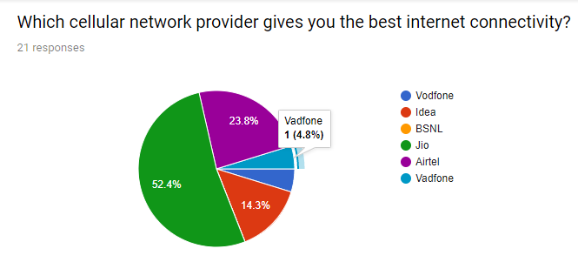

Most of the students about 66.7% of students are of the opinion that their service provider provides the best offers compared to another service provider, while only 33.3% of students are of the view that their service provider does not provide them good offers compared to another network providers.

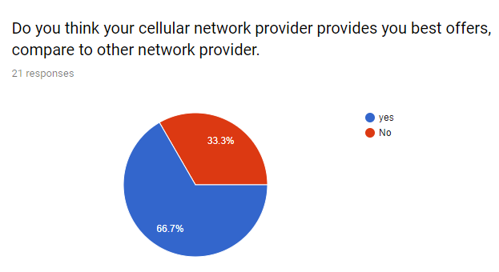

57.1% of students spend between 100 to 300 rupees on their monthly recharge, however, 28.6% of students are spending money between 300 to 700 rupees on their monthly recharge, while few students about 14.3% spend between 100 to 10 rupees on their monthly recharge.

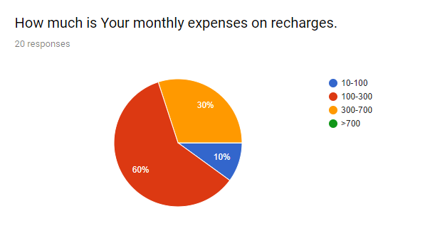

Most of the students i.e. 55% of the students are satisfied with their network provider they are the user of jio and Airtel cellular network provider, however, 45% of students are not satisfied with their network provider they are the users of Idea and Vodafone cellular network provider, the reason behind this is they are not getting proper network coverage.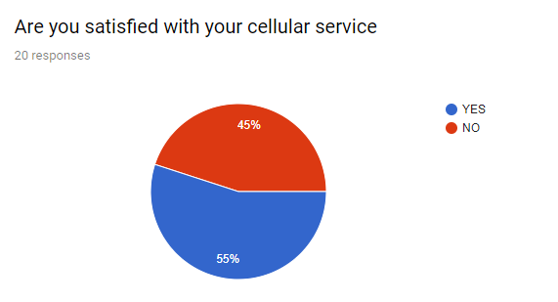

### Conclusion

As per the survey, it is concluded that Jio service provider provides the best service and internet connectivity. Most of the students are spending between 100-300 rupees on their monthly recharge, And more then half of the students are satisfied with their network provider and less than half of the students are not satisfied with their network provider because of the network coverage issue.

**Recommendation**

* Port your Sim card to another operator.
* Upgrade your Sim card.
* Clear browsers cache and cookies of the browser for fast internet connectivity.
* Get customer support from your cellular network provider.

**List of reference**

1. https://en.wikipedia.org/wiki/History_of_mobile_phones
2. https://en.wikipedia.org/wiki/1G

**Appendix**

**URL:-** https://goo.gl/forms/uGq3QLD1qQo8munZ2

